**NAMA : JESSICA GUSTIN RAHAJENG**

**NIM : L200170026**

**KELAS : A**

**UJIAN AKHIR SEMESTER**

1. Membuat topologi dengan menggunakan router generik

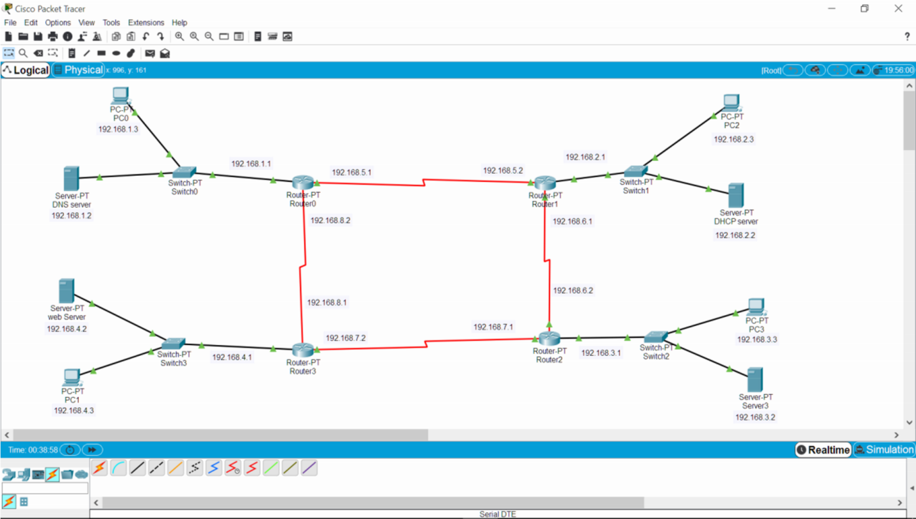

1. Mengkonfigurasi pengalamatan IP

|  |  |  |
| --- | --- | --- |
| Router 0 | Server DNS | PC 0 |
| SE 2/0 (IP Address 192.168.5.1) | IP Address 192.168.1.2 | IP Address 192.168.1.3 |
| SE 3/0 (IP Address 192.168.8.2) |
| Fa 0/0 (IP Address 192.168.1.1) |

|  |  |  |
| --- | --- | --- |
| Router 1 | Server DHCP | PC 2 |
| SE 2/0 (IP Address 192.168.6.1) | IP Address 192.168.2.2 | Otomatis sesuai pengaturan dhcp yang dibuat  (IP Address 192.168.2.3) |
| SE 3/0 (IP Address 192.168.5.2) |
| Fa 0/0 (IP Address 192.168.2.1) |

|  |  |  |
| --- | --- | --- |
| Router 2 | Server3 | PC 3 |
| SE 2/0 (IP Address 192.168.7.1) | IP Address 192.168.3.2 | IP Address 192.168.3.3 |
| SE 3/0 (IP Address 192.168.6.2) |
| Fa 0/0 (IP Address 192.168.3.1) |

|  |  |  |
| --- | --- | --- |
| Router 3 | Server Web | PC 1 |
| SE 2/0 (IP Address 192.168.8.1) | IP Address 192.168.4.2 | IP Address 192.168.4.3 |
| SE 3/0 (IP Address 192.168.7.2) |
| Fa 0/0 (IP Address 192.168.4.1) |

* DNS server

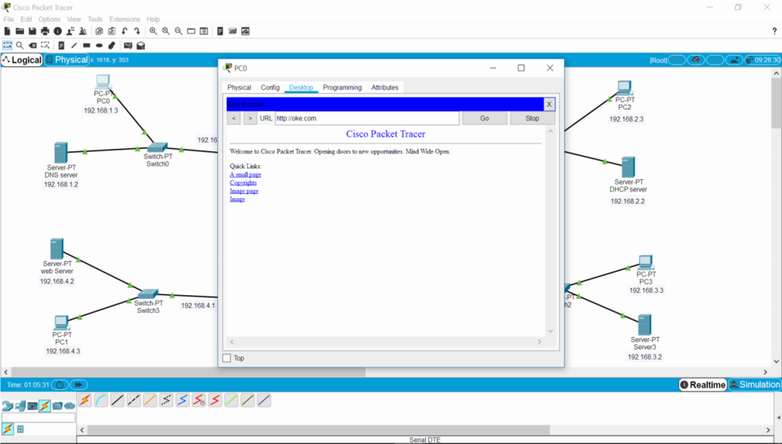

* DHCP Server

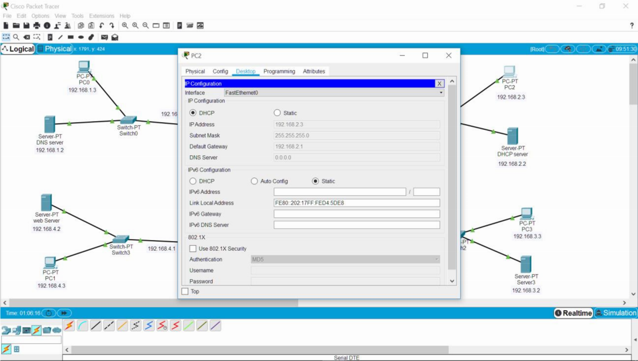

* Server3

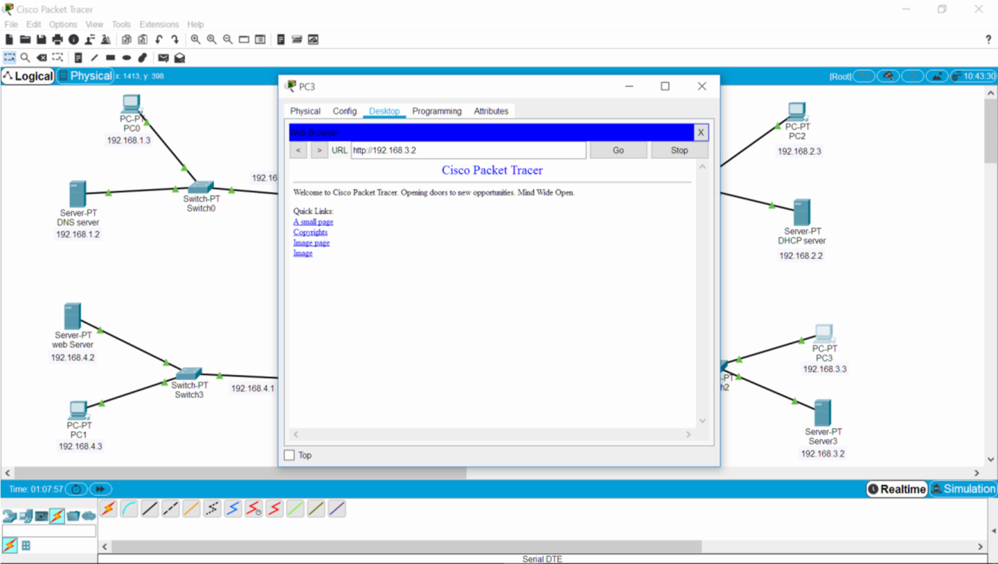

* Server Web

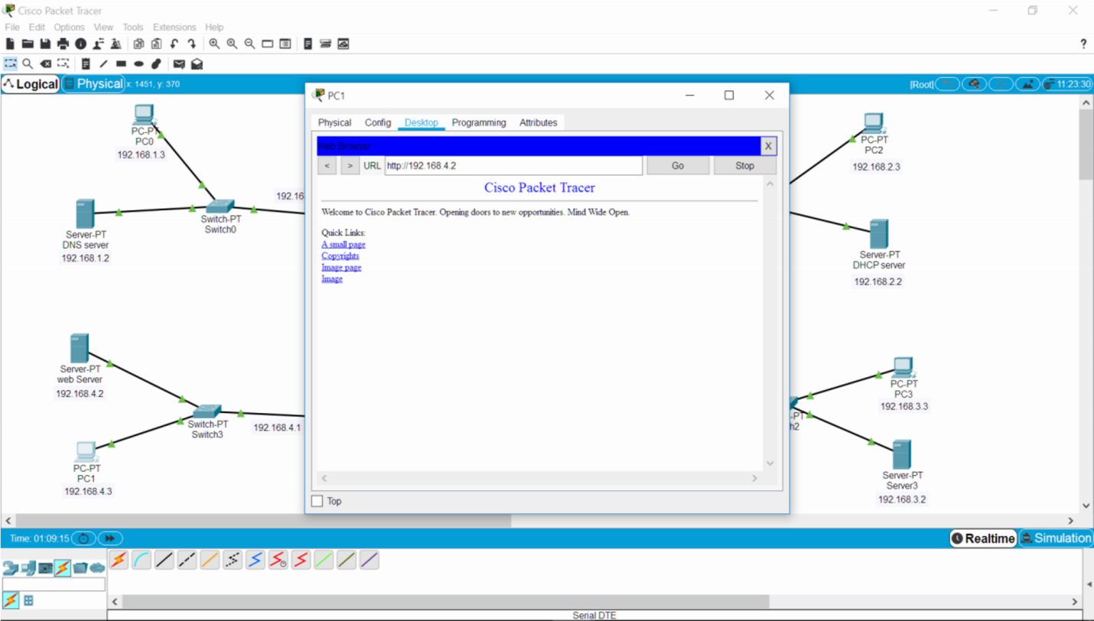

1. Konfigurasi router dinamis menggunakan protocol routing RIP
2. Router 0

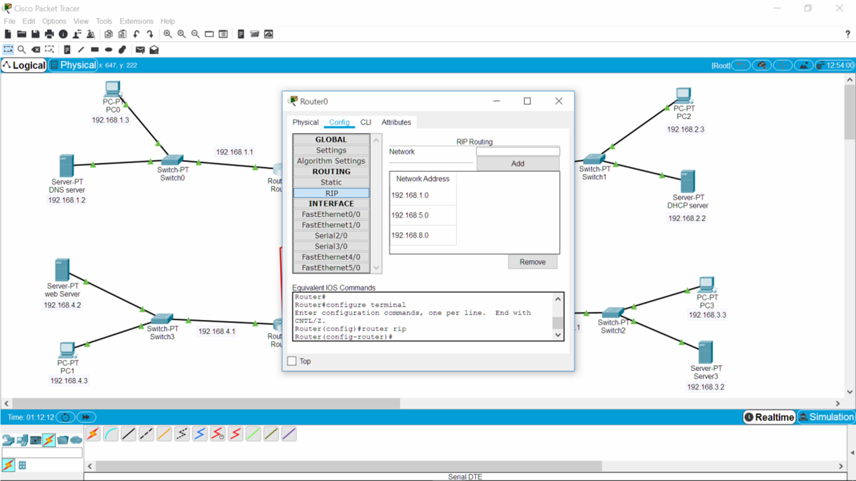

1. Router 1

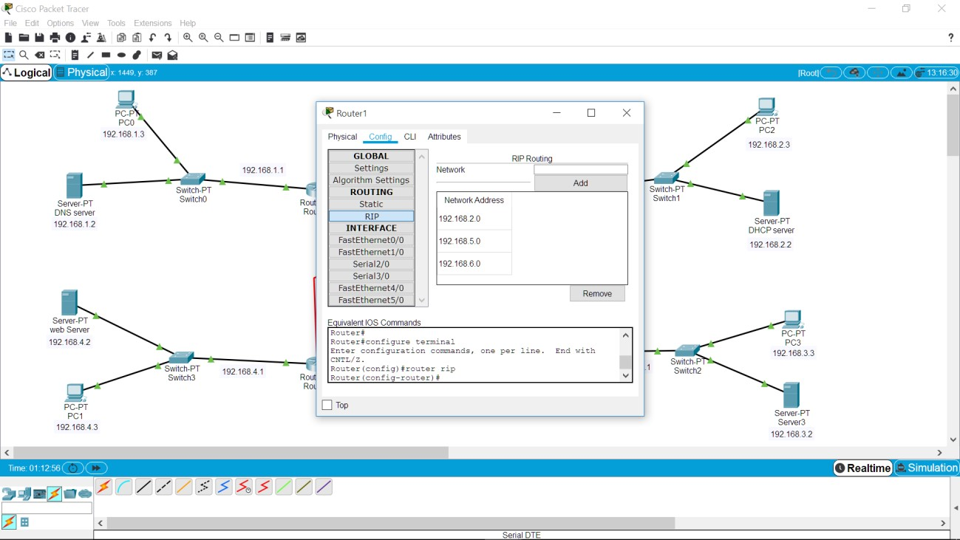

1. Router 2

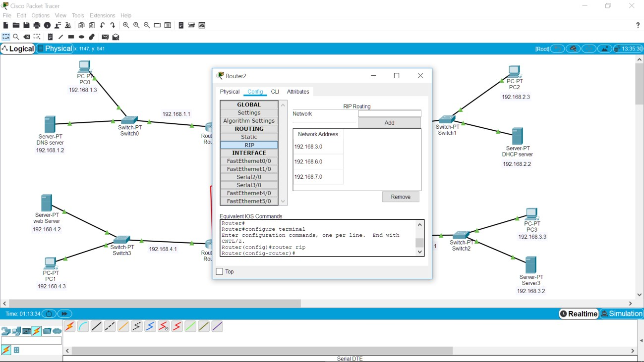

1. Router 3

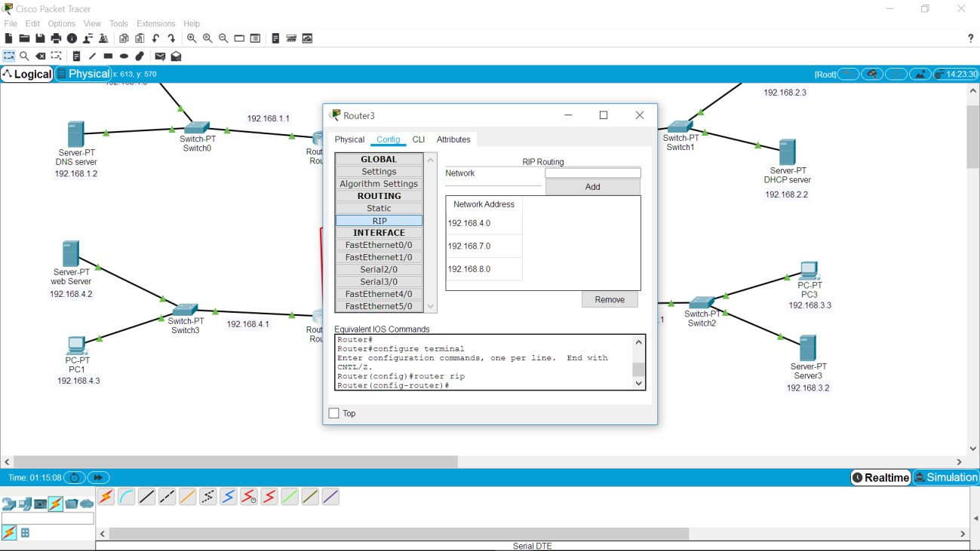

>> Ping ketiga router statis

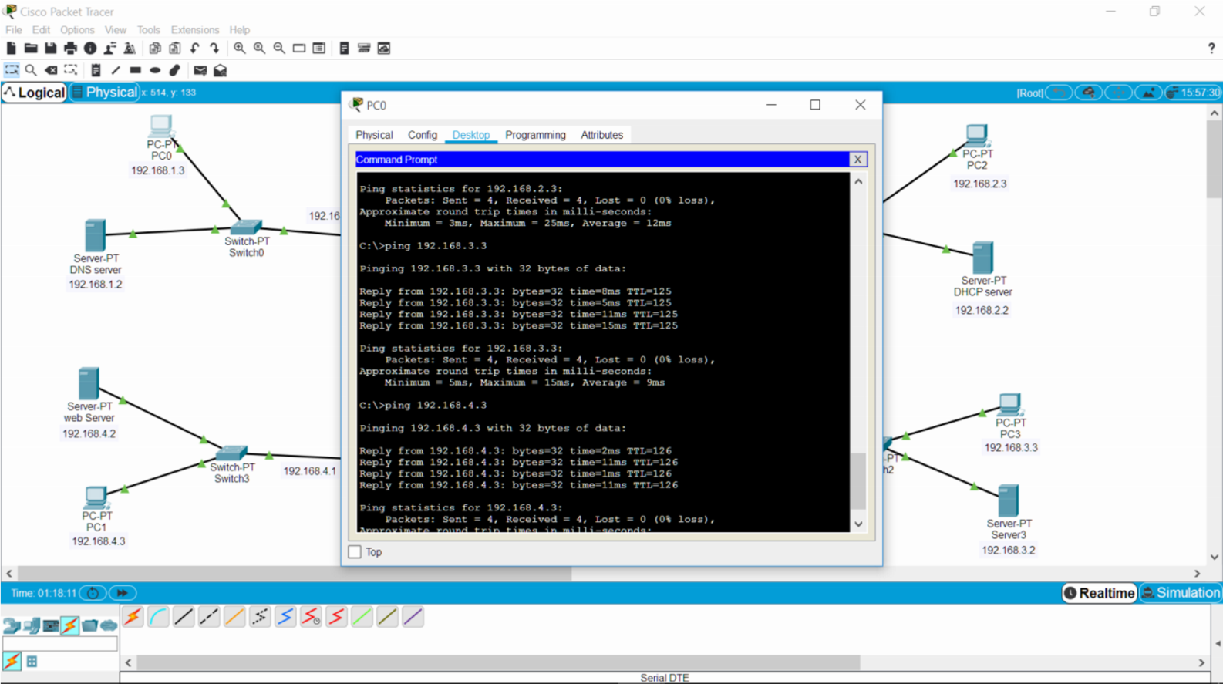

*>>* Router dinamis(uji konektivitas PC ke server antar router)

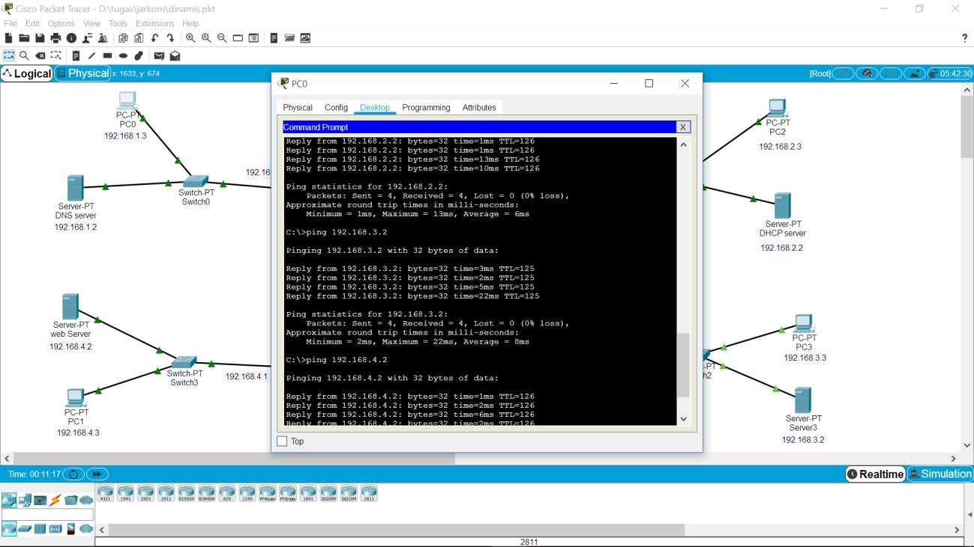

1. Uji konektivitas antar PC
2. Router 0

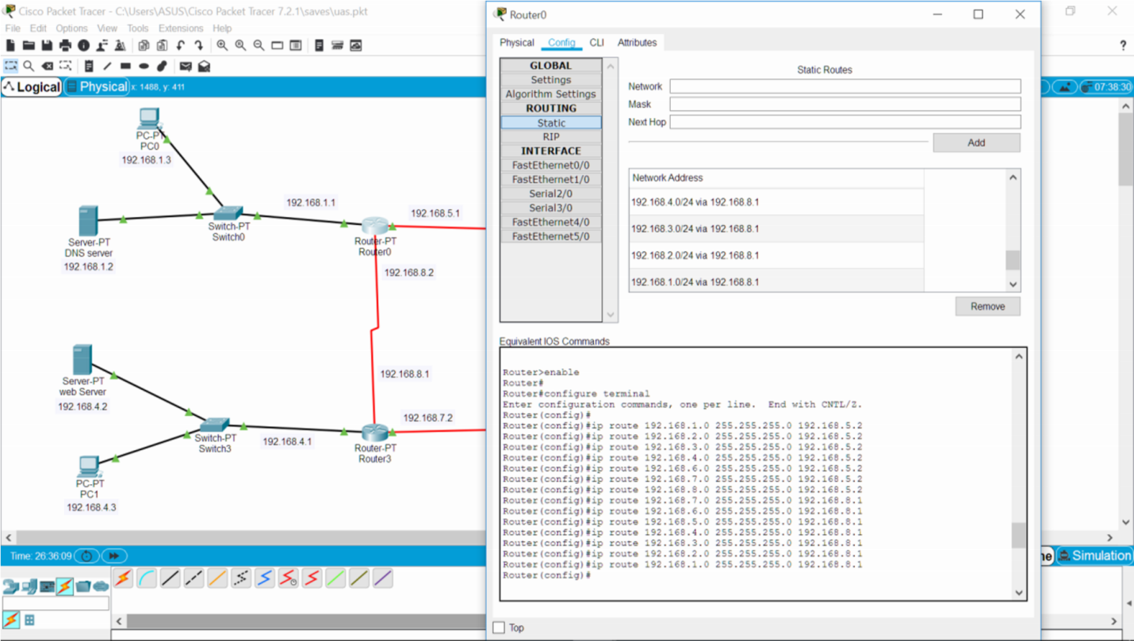

1. Router 1

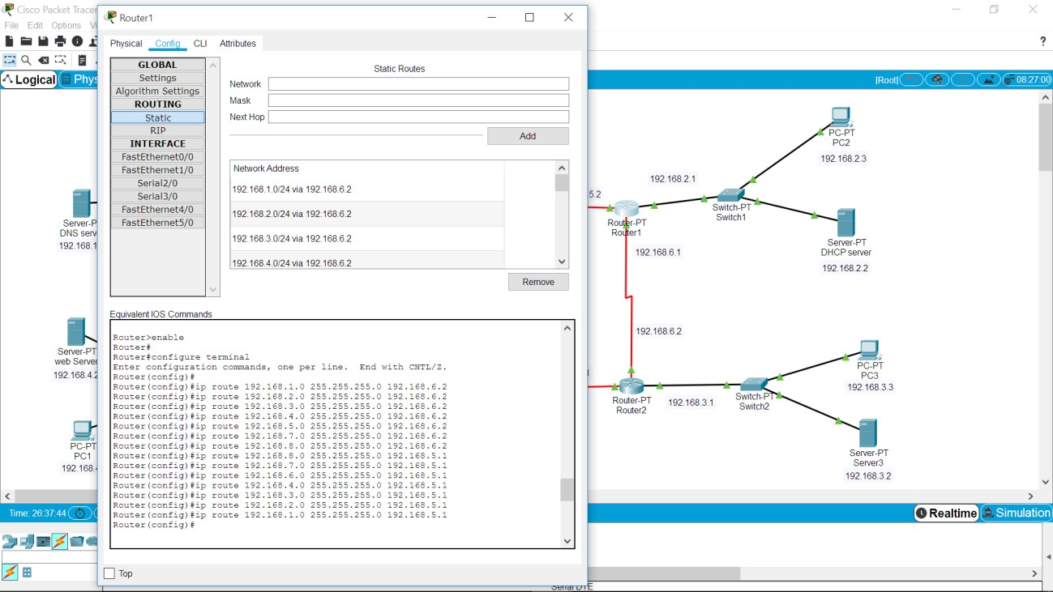

1. Router 2

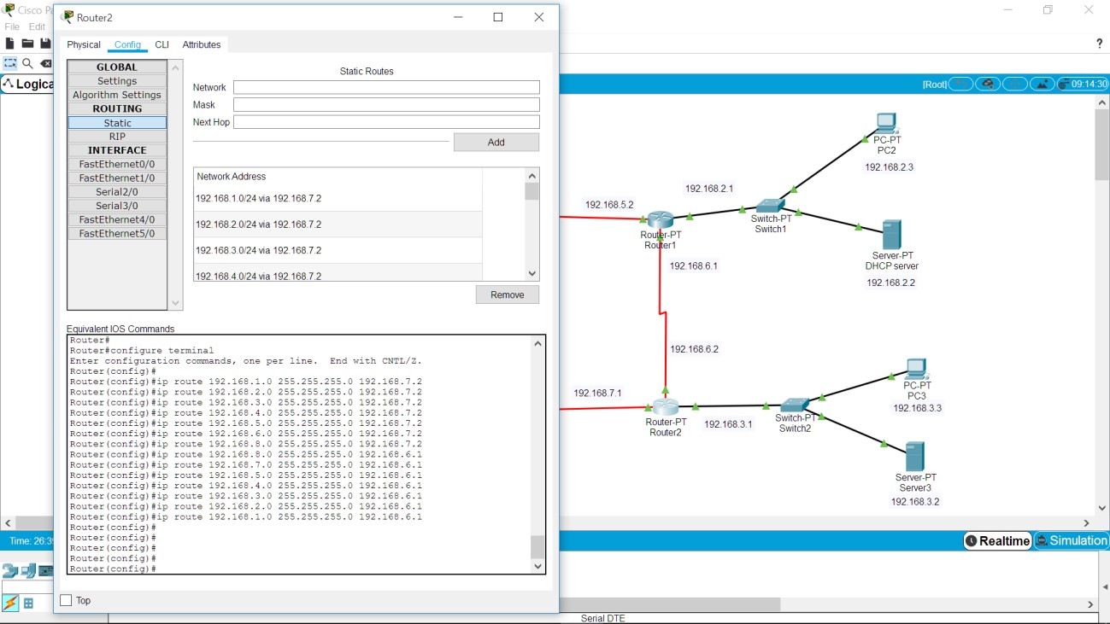

1. Router 3

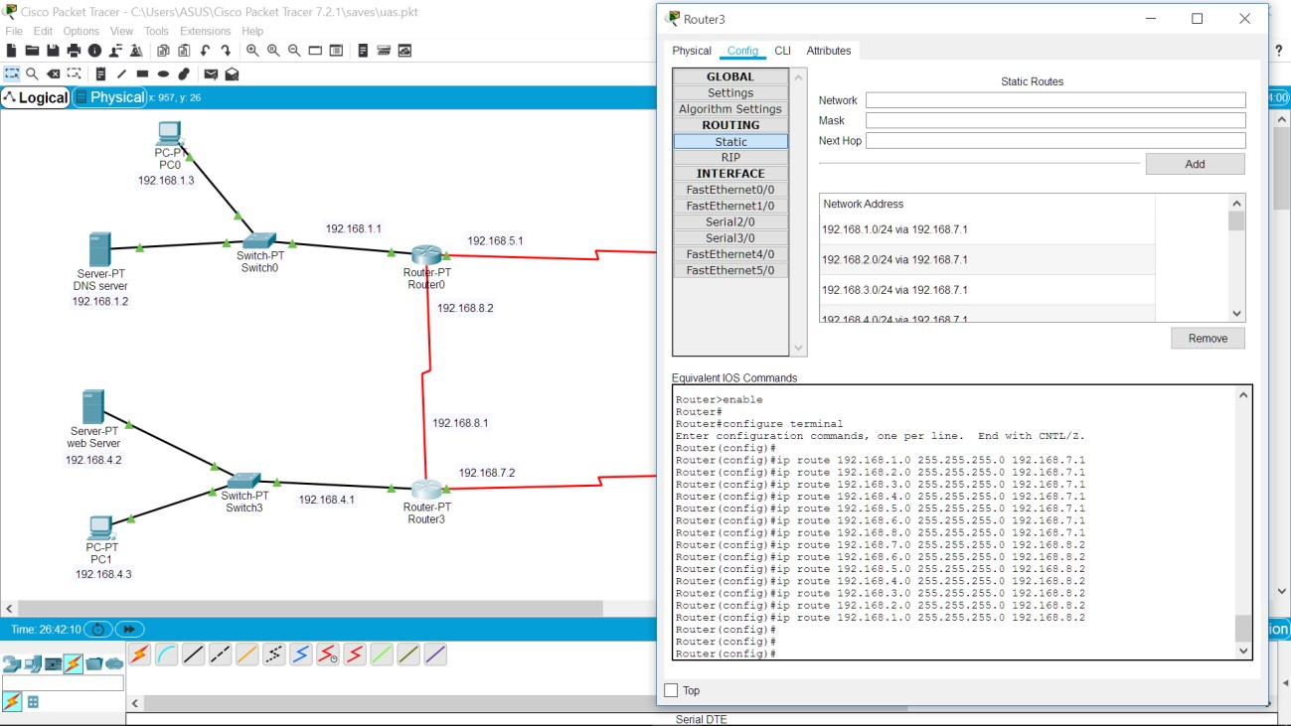

>> Router statis(uji konektivitas antar PC)

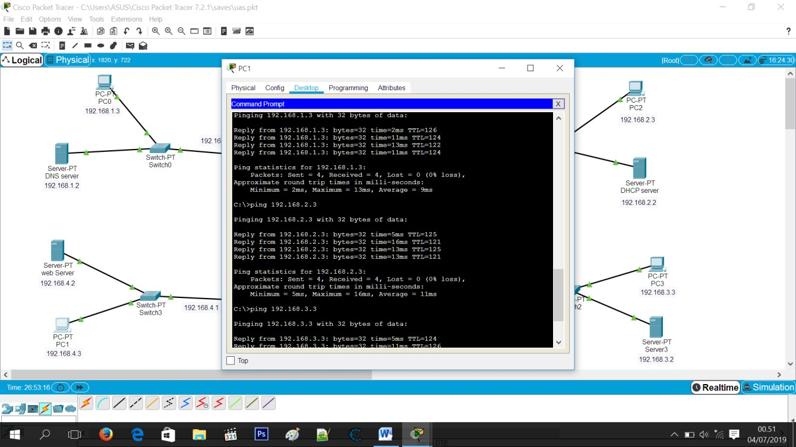

>> Router statis (uji konektivitas PC ke server antar router)

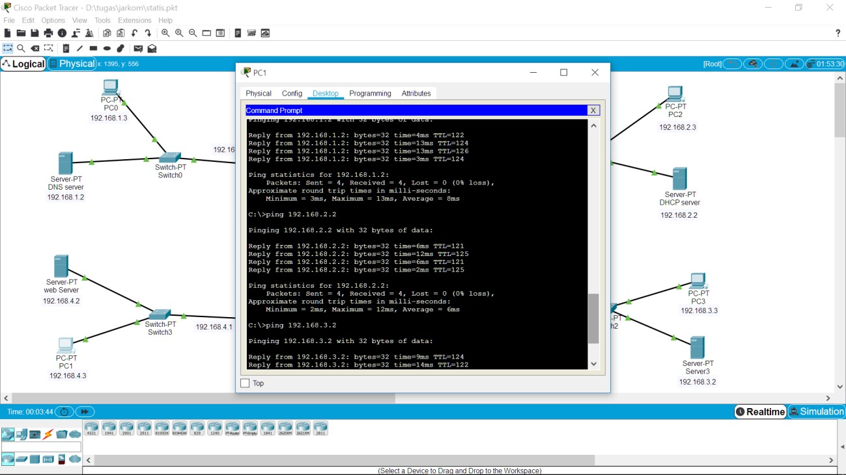

1. Menggunkan access list untukmembatasi 1 PC saja yang dapat mengakses server web

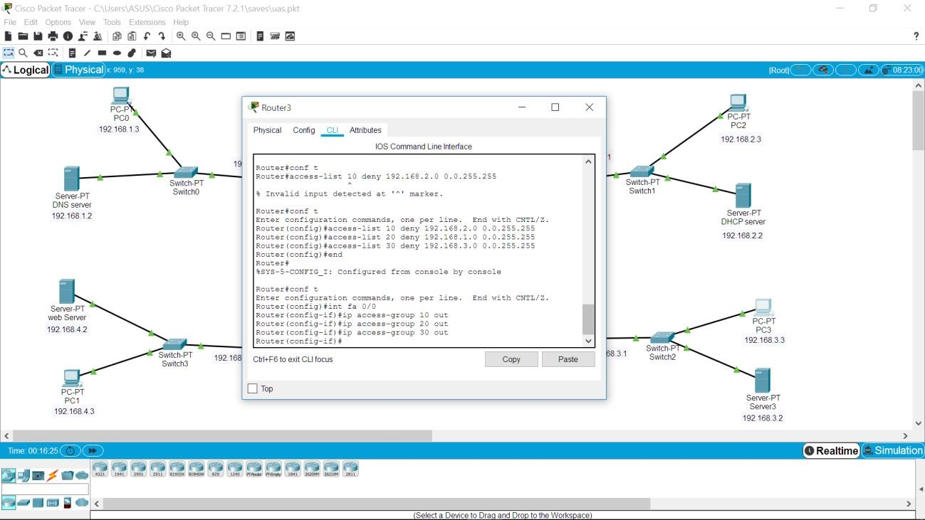

1. aksesdengan PC 0

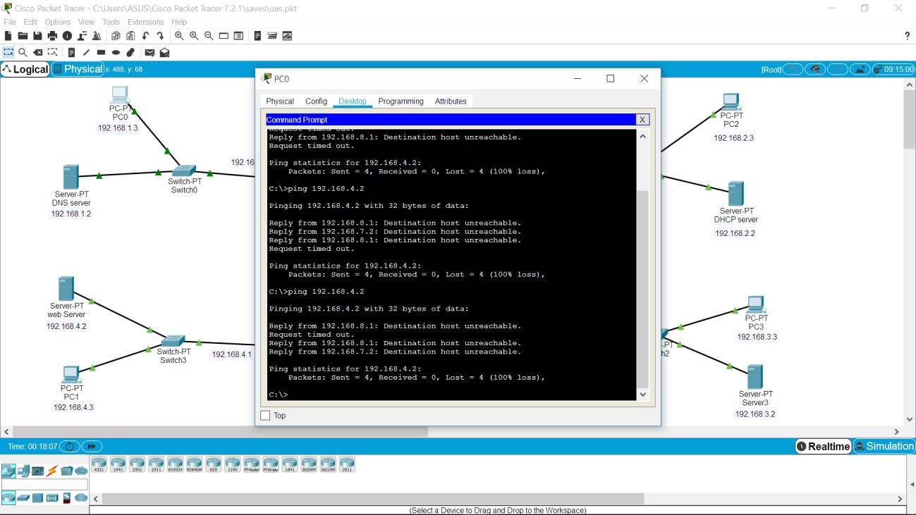

1. Akses dengan PC 2

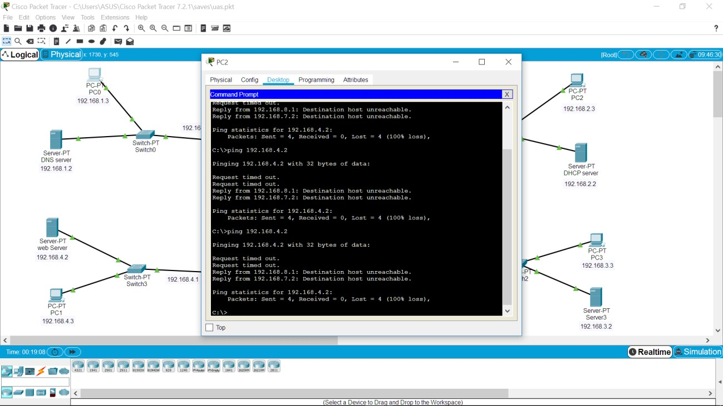

1. Test aksesdengan PC 3

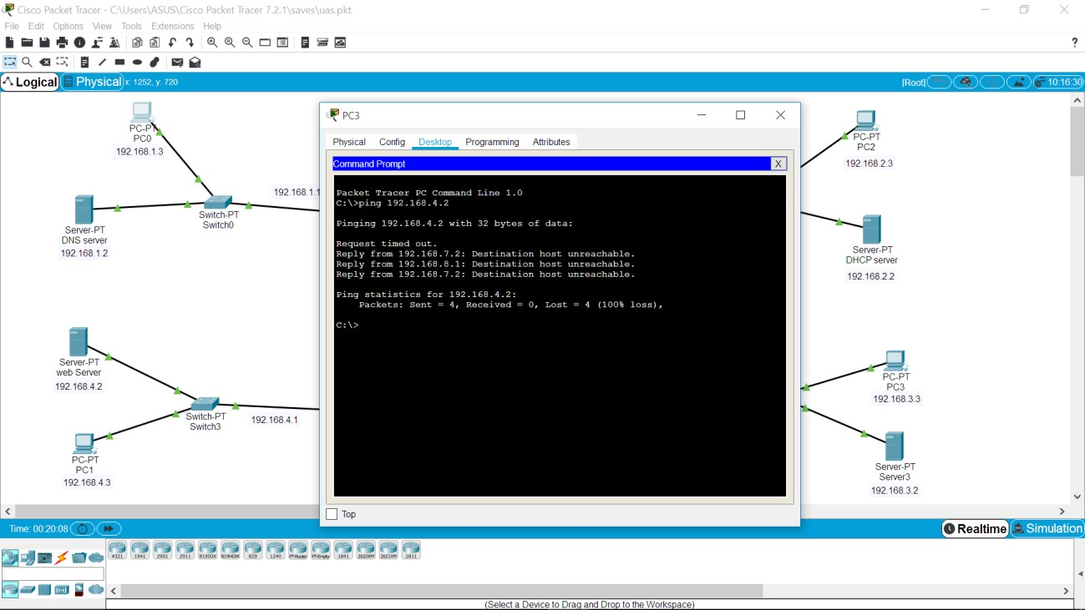

1. Akses dengan PC 1

